**EX. NO: 1**

**DATE: 18/08/2020**

**Basic Linux Commands**

**The linux commands like**

**i) ls**

**ii) cd**

**iii) vi**

**iv) cat**

**v) mkdir**

**vi) rmdir**

**vii) mv**

**viii) cp**

**ix) pwd**

**x) whoami**

**were executed.**

**Screenshots:**

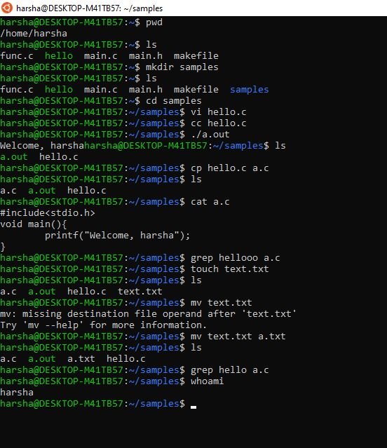

**Result:**

**Hence, Basic Linux Commands Have Been Executed Successfully.**